**Ques 1 :**

**i. Implement Insertion Sort (The program should report the number of comparisons)**

#include<iostream>

#include<fstream>

using namespace std;

const int arrSize=500;

template<class t>

class insertionSort{

t arr[arrSize];

public:

void getData(int n){

for (int i=0; i<n; i++){

int r=rand()%100;

arr[i]=r;

}

}//input random values

void displayData(int n){

for (int i=0; i<n; i++){

cout<<"\t"<<arr[i];

}

}//output the array

int iSort(int n){

int count=0;

for (int i=0; i<n; i++){

t key=arr[i];

int j=i-1;

while(j>=0 && arr[j]>key){

arr[j + 1] = arr[j];

count++;

j=j-1;

}

arr[j + 1] = key;

count++;

}

cout<<endl<<"-> Number of comparisions : "<<count<<endl;

return count;

}

};

int main(){

insertionSort<int> obj;

int size=30;

int i=0;

int count=0;

int iter=20;

ofstream excelFile;

excelFile.open("Q1_excel.csv");

excelFile<<"SIZE(n)"<<","<<" COMPARISIONS"<<","<<"Log (n)"<<","<< "n Log (n)"<<endl;

while (i<iter && size<=arrSize){

cout<<endl<<endl<<"================================"<<endl;

cout<<endl<<"-> Size of the array - "<<size<<endl;

obj.getData(size);

cout<<endl<<"-> Array before sorting - " ;

obj.displayData(size);

count=obj.iSort(size);

excelFile<<size<<","<<count<<endl;

cout<<endl<<"-> Array after sorting - ";

obj.displayData(size);

size=size+20;

i++;

}

excelFile.close();

}

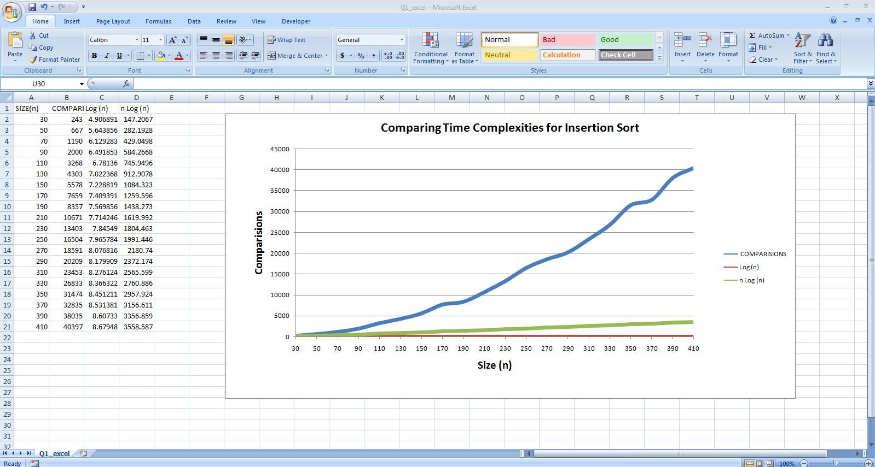

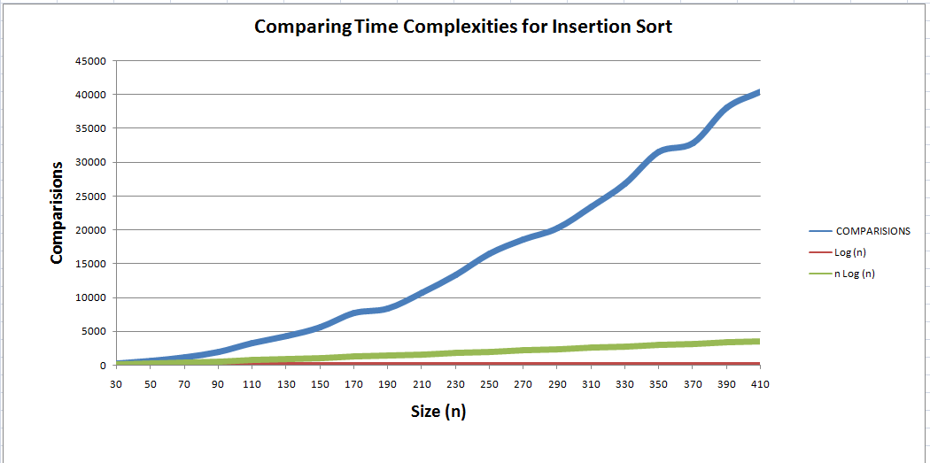

**Ques 1 :**

**ii. Implement Merge Sort (The program should report the number of comparisons)**